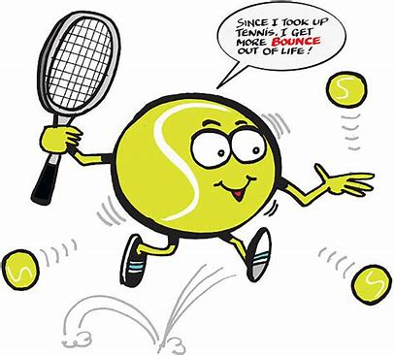
Applications are now welcomed for the 2024 Seniors Tennis GB (STGB) / LTA
Participation grant scheme

Grants of up to £400 are available to help run

- a recreational competition for seniors aged 30+ using the new ITF World Tennis Number

OR

- a ‘let’s start tennis’ scheme aimed at encouraging new players to start playing tennis.

The £400 can be used towards trophies, organiser time, marketing etc. Reasonable entry fees can be charged to generate some money.

Must-do
Submit results using LTA Competition Software such as Results Manager so that the resulting World Tennis Number is updated.
Submit a report describing the activity, numbers, what worked and what improvements could be made.

Schemes must be sustainable – for example showing this is the first of what you hope to be a number of events and communications.

NB priority will be given to first time applicants.

Use this link to apply:

https://fs18.formsite.com/ltaadmin/sk1j27flaa/index

All marketing and communications material must use the STGB and LTA logos.
Application deadline is Wednesday 1st May 2024.
Any questions? Contact Anne Clark ( annejclark57@gmail.com )

